**Expiriment NO: 3**

**Aim : Familiarisation of linux commands**

**CO2 : Perform system administration task**

procedure :

**1)pwd**

To find out the path of the current working directory (folder) you’re in.

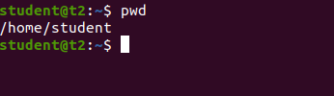

**2) history**

To review the commands you have entered before. command number to run a command from history.

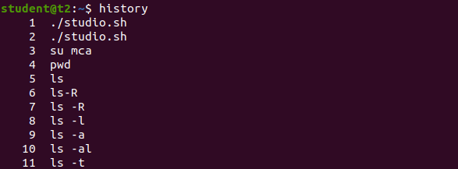

**3)man**

This will show the manual instruction of the command.

*man ls

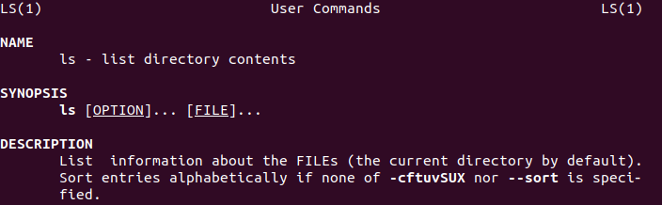

**4)ls**

The ls command is used to view the contents of a directory. By default, this command will display the contents of your current working directory.



**4.1)ls -a**

This will show the hidden files

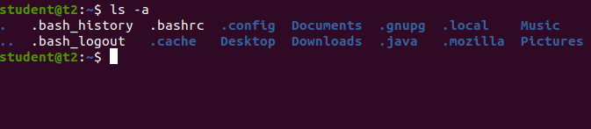

**4.2)ls -R**

This will list all the files in the sub-directories as well

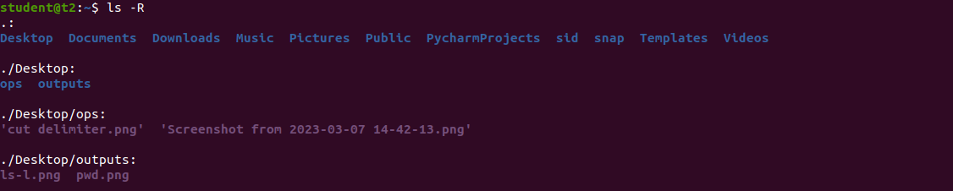

**4.3)ls –l (Long listing)**

This command displays the contents of the current directory in a long listing format, one per line

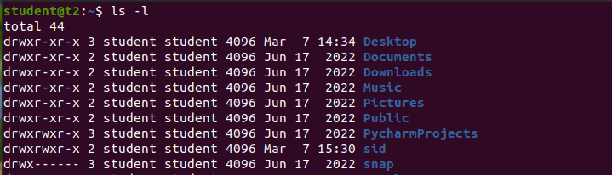

**4.5)ls -al**

It will list the files and directories with detailed information like the permissions, size, owner, etc.

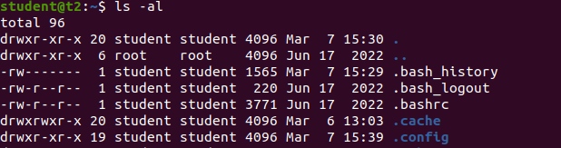

**4.6)ls -t**

It will lists files sorted in the order of “last modified”

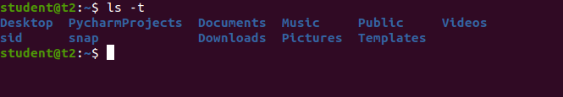

**4.7)ls -r**

It will reverse the natural sorting order. Usually used in combination with other switches such as ls -tr. This will reverse the time-wise listing.



**5)mkdir**

Use mkdir command to make a new directory. Use the p (parents) option to create a directory in between two existing directories.

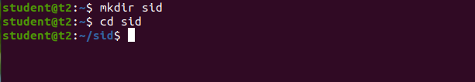

**6)rmdir**

Rmdir is used to remove directory.

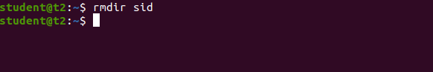

**7)cd**

To navigate through the Linux files and directories.

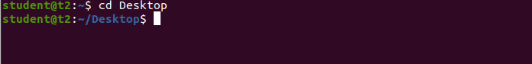

**7.1)cd ..** (with two dots) to move one directory up

